

Principle of operation: Reed Level Transmitter works on the principle of Variable Resistance where resistors are connected to reed switches in a ladder network. The magnet inside the Float chamber actuates the Reed switch thereby providing a variable resistance output proportional to float position. This resistance is connected to electronic board which converts it into analogue output.

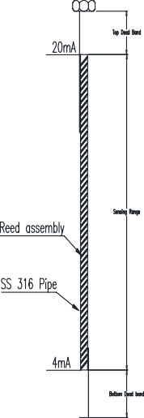

Mounting Options:

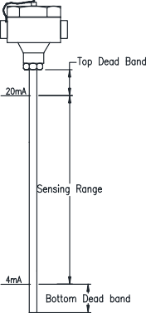 | 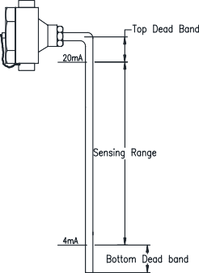 | 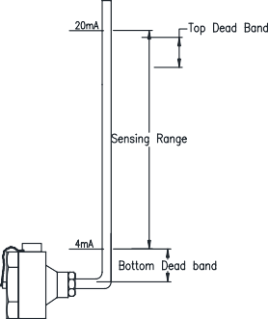

Specification:

Input: 24V DC
O/p: 4-20mA, 0-10V DC, RS 485
Resolution: 5mm, 10mm Max. temperature : 150° C
C/C: 100mm to 6000mm
Enclosure: Weatherproof, Flameproof MOC: SS 304, SS 316, PP

Ordering code: MLI T – A – B – C – D - E A – Enclosure
WP – Weatherproof Enclosure, Cast Aluminium FP – Flameproof Enclosure, Cast Aluminium
SP – Special Enclosure

B – Resolution
05 – 5mm
10 – 10mm

C – Output
I – 2 wire 4-20 mA
V – 3 wire, 0-10V DC R – RS 485

D – Pipe MOC
4 – SS 304
6 – SS 316 P – PP

E – Mounting Option
A – Enclosure Top
B – Enclosure top at right angle
C – Enclosure bottom at right angle

Levtron Instruments Pvt Ltd.
Office No 2, 1st floor, plot no 6, Pandhari Industrial estate, Shivane. Pune 411023, Contact:09579430012/9730042725E-mail:sales@levtron.in;Web: www.Levtron.in

